Generics

Generics - An enhancement to the type system that supports operations on objects of various types(points to its dynamic nature) while providing compile-time type safety.
They allow a type or method to operate on objects of various types(agin quite same what interface does we can provide various types) while providing compile time safety.

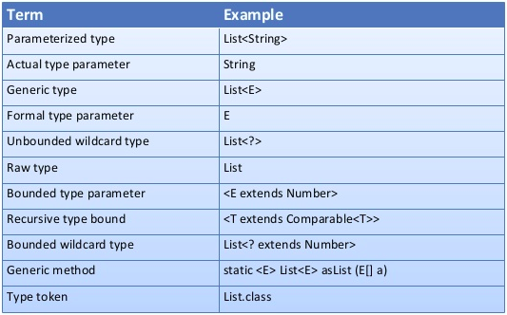

Only classes, interfaces and methods can be defined as generic
Enums and inner classes cannot be declared as generic
By Convention we use single letter to define formal type parameters
E - > Element
K -> Key
V -> Value
T ->Type etc.
Naming follow the same rules as variable declaration

Constructors doesn’t specify formal type parameters
types are not allowed in constructor
Class Node<E>{
Node<E>(){............ } // wrong
}
Formal type parameters cannot be used to create objects
E reference = new E(); //wrong
A formal type parameter cannot be used in static context.

//
Here it is to be noted that generics can be used as much as interface , no object can be made and cannot be used with new but can be used on LHS

Wild Cards and Type Erasure
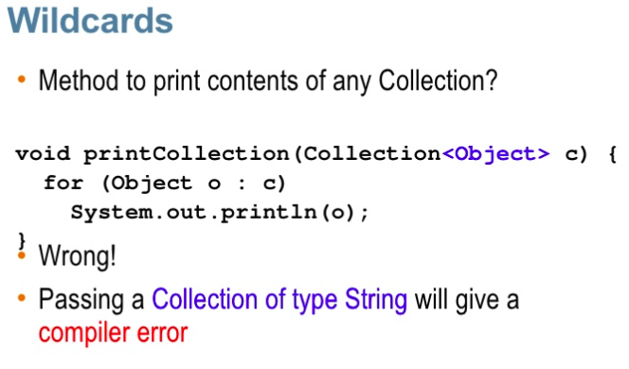

So as we see though in Object we can put of any type but not in generics

My vocab

generic types T value
extension to generic types -----> Collection<T> value also can be called formal parametres

Above both behave diffrently and extension have a special feature called wild cards

